Exam 1 Review

Table of Contents

Notes from Instructor 2

Topics 2

CH1 - CH5 2

CH6 2

CH7 2

CH8 2

CH14 2

PowerPoint Review 3

Ch6- Constraint Satisfaction Problems 3

Notation 3

Ch7 – Logical Agents 4

Ch8- First-Order Logic 5

Notation 5

Ch14- Probabilistic Reasoning 6

Bayes Theorem 6

# Notes from Instructor

# Topics

### CH1 - CH5

PEAS

Draw A*

Draw RBFS

Greedy Algorithm

Draw minimax search tree

be able to alpha-beta prune a tree, simply circling the node

### CH6

CSP

### CH7

### CH8

∀ and ∃ notation

### CH14

Bayes Theorem

# PowerPoint Review

## Ch1 thru Ch5

### Good Behavior

#### Good behavior is determined by how well the agent performs

#### Measurement occurs:

#### 1 from the reference frame of the environment state

#### 2 what one wants in the environment

#### Rational Agent criteria

#### 1 performance measure

#### 2 agents’ prior knowledge

#### 3 actions availed

#### 4 percept sequence to data

PEAS

Performance, Environment, Actuators, Sensors

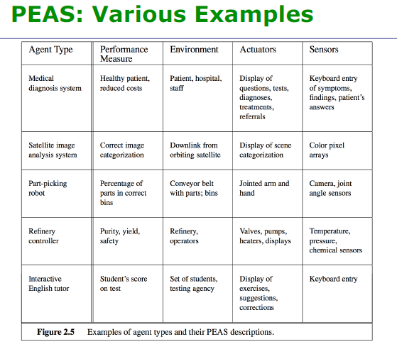

Task Environment Assessment

|  |  |  |  |  |  |
| --- | --- | --- | --- | --- | --- |
|  | Def | Reason | Pros | Cons | Hard |
| Fully observable | sensors give full env state | sensors obsv all aspects relevant to actions | agent needs less memory |  |  |
| Partially observable | sensors don’t give full env state | noisy env, inaccurate sensors | agent needs less sensors | agent can’t discover itself in env | X |
| Single Agent | one agent only | the agent is alone | simple perf measure |  |  |
| Multiagent | B's perf measure depends on A's | one agent affects another |  | complex perf measure | X |
| Deterministic | next STATE is determined by current | states are fixed | a solution can be reached |  |  |
| Stochastic | next STATE independent from current | states are variable |  | solution not guaranteed | X |
| Episodic | 1 action per episode.  Episode independent of each other | agents experience is based on pattern |  |  |  |
| Sequential | actions effect future decisions | agents experience is based on decisions |  | solution not guaranteed | X |
| Static | env stays stationary until agent acts | environment is fixed with time |  |  |  |
| Dynamic | env change while agent thinks | environment is variable with time |  |  | X |
| Discrete | finite state, finite time, finite percepts and actions |  | processing time irrelevant |  |  |
| Continuous | many states, infinite time, infinite percepts and actions |  |  | time it takes to find solution might miss it | X |
| Known | designer knows all outcomes.  Agent is programed with them |  | solution can be reached |  |  |
| Unknown | design does not know outcomes.  Agent must learn |  |  | agent might not learn enough | X |

## Ch6- Constraint Satisfaction Problems

66 Slides

Map Color, Schedule, Word

### Notation

■ X is a set of variables, {Xi, …, Xn}.

■ D is a set of domains FOREACH X, {Di, …, Dn}, one for each variable.

■ C is a set of constraints that specify allowable combinations of values.

■ n = number of variables

■ d = domain size

■ Alldiff( X, Y, Z) means that X, Y and Z are all different and can not match

### Formulas

■ Branching at top = n * d

■ Next level down = (n-1) * d

■ Complete assignments = d^n

### Definitions

### Unary = one variable

### Binary = two variables

### Higher order = 3 or more (Cryptarithmetic)

### Backtracking – choose values, until violation or success, on violation, trim branch and don’t go back

Efficiencies for backtracking:

### Minimum Remaining Values

### Least Constraining Value

### Arc consistency – simplest form of constrain propagation, when one variable loses a value, all arcs must be checked

### Forward Checking – keep track of all legal values available for each variable, when any one has no more, terminate

## Ch7 – Logical Agents

100 Slides

54

### Definitions

* Knowledge Base
  + Representation of facts, called sentences
* Sentence
  + Axiom
  + Expressed in knowledge representation language
  + Assertion about the world
* Reasoning

### Concepts

* AI system
  + Knowledge base
  + Reasoning
* Add to KB
  + Tell
* Query KB
  + Ask
* Wumpus World Characterization
  + Deterministic
  + Static
  + Discrete
  + Single Agent
* Inference Algorithm
  + One which Derives only entailed details is called:
    - Sound / truth preserving
  + One which can derive ALL entailed details is called:
    - Complete
* Proof
  + Procedure of getting a sound inference
* A sentence is
  + Valid – true for all
    - α ⊨ β
  + Satisfiable – true for some
    - ¬α ⋁ β
  + Unsatisfiable – false for all
    - ¬(¬α ⋁ β)

### Notation

* M(α) – defines the set of all models of α
* α ⊨ β (i.e. sentence α entails sentence β
  + α ⊨ β if and only if, in every model in which α is true, β is also true
  + α entails β
* KB ⊨ α
  + KB entails α
  + Sentences α may be inferred from KB using inference
  + procedures.
* KB ⊦i α
  + “α is derived from KB using inference procedure i”

## Ch8- First-Order Logic

50 Slides

### Notation

* Constants KingJohn, 2, UCB, ...
* Predicates Brother, >, ...
* Functions Sqrt, LeftLegOf, ...
* Variables x, y, a, b,...
* Connectives ∧, ∨, ¬, ⇒, ⇔
* Quantifiers
  + ∀ typically used with ⇒
  + ∃ typically used with ∧

## Ch14- Probabilistic Reasoning

68 Slides

### Conditional Probability

P(A|B) = P (A ∩ B) / P(B)

Probability of being a man and an alcoholic = 0.0225

What is the probability of being a man, given you’re an alcoholic?

P(A|B) = 0.0225

P(B) = p male = .5

P(A|B) = 0.0225 / 0.5 = 0.445

### Bayes Theorem

P(A|B) = P(B|A) * P(A) / P(B)